**<Diagnostics on the technology divide on Aruba>**

**<Draft 1: May 16th, 2022>**

**<Logo Futura>**

**Acknowledgements**

Cornerstone Economics expresses warm appreciation to Futura Foundation and the Aruba Chamber of Commerce for distributing the survey link on social media and by email, and to the Central Bureau of Statistics Aruba for providing geospatial data and maps to support the visualization.

This report was prepared by Cornerstone Economics – Rendell de Kort and Lay Hing de Kort-Yee, with the assistance of: Kiandra Donata, Jimena Borja, Jerahmy Arends, Jaymarc Werleman, Giseth Ramirez, Marlin van der Linden, Catalina Saavedera and Dean Torres.

**Contact**

Queries and comments can be addressed to Rendell E. de Kort, partner, Cornerstone Economics. E-mail: [rendell@c-economics.com](mailto:rendell@c-economics.com)

<logo Cornerstone Economics>

Contents

Acronyms 5

Summary 6

Economic Snapshot of the Digital Divide 7

Profile 9

Demographics of respondents 9

1. Access 11

1.1 Household broadband access 11

1.2 Disparity in broadband uptake between urban and rural households 12

2. Use 14

2.1 Internet users as a share of individuals 14

2.2 Individuals using the internet to interact with public authorities 15

2.3 People buying online 16

2.4 Share of small businesses making e-commerce sales 17

2.5 Share of businesses with a web presence 18

3. Innovation 19

3.1 Share of start-up firms 19

3.2 Businesses accepting alternative means of payment 20

4. Jobs 22

4.1 Workers receiving employment-based training 22

5. Society 24

5.1 Individuals aged 55-74 using the Internet 24

5.2 Women as a share of all 16–24-year-olds who can program 25

5.3 Disparity in Internet use between men and women 25

5.4 Individuals who use digital equipment at work that telework from home 26

6. Trust 28

6.1 Internet users experiencing abuse of personal information or privacy violations 28

6.2 Individuals not buying online due to payment security concerns 28

6.3 businesses in which ICT security and data protection tasks are mainly performed by own employees 30

7. Market openness 31

7.1 Share of businesses making ecommerce sales that sell across borders 31

Methodology 33

Individual survey 33

Business survey 33

Calculation of digital divide estimates 33

# Acronyms

BES Bonaire, Sint Eustatius and Saba

CAS Curacao, Aruba and Sint Maarten

CBS Central Bureau of Statistics Aruba

CENSO Civil Registry and Population Register

DSL Digital Subscriber Line

GDP Gross Domestic Product

ICT Information and communication technologies

OECD Organization for Economic Co-operation and Development

NDA National Digital Agenda

SIDS Small Island Developing States

SVB Social Insurance Bank

WEB Water and Electricity Company Aruba

# Summary

To articulate Aruba’s national vision for digitally inclusive growth, Stichting Futura requested Cornerstone Economics in the formulation of a strategic primer for the National Digital Agenda (NDA). As a point of reference, the OECD going digital toolkit was utilized. The operationalization entailed the collection of secondary data and the collection and analysis of primary data through the execution of surveys amongst a representative sample of Aruba’s population and businesses. The surveys form a baseline assessment for informed and evidence-based decision making relating to the possible gaps in technology and digital thinking in Aruba.

The OECD framework consists of seven policy dimensions that Aruba must focus on to become digital-ready, namely:

1. Access
2. Use
3. Innovation
4. Jobs
5. Society
6. Trust
7. Market openness

**The results suggest that Aruba lags significantly in 3 of the 7 dimensions, namely in innovation, trust, and market openness.** While for access, use and society Aruba however close to the global average. On balance this results in a negative overall ranking compared to the countries included in the OECD digital divide database.

**Access and Use are comparatively well in line with the global averages.** This implies that the fundamental communication infrastructure that underpins the global transformation is well available to the general population. A large portion of the population can access the internet, is connected to social media and have the availability of enabling hardware. Contrary to many other countries, there is little evidence of a significant divide between rural and urban populations, suggestive of adequate social inclusion. Businesses are predominantly micro (78 percent) and by and large have a social media presence.

**For Aruba, the more relevant question revolves around how technology is leveraged to empower businesses from merely a social media presence to digital exporters and Individuals from passive social media consumers to global value creators.**  The level of innovation and sophistication appears low, with a low share of business start-ups and a worrisome low level of business making e-commerce sales across borders. The latter is apparent from the fact that even though Aruba has an open economy with high services exports and import of goods, 72% of firms do not sell across borders, with only a minimal share of businesses able to offer payment methods facilitating such transactions. On the individuals end, 13.3% of the population do not have access to a credit card or other payment tools to complete online payments. Facilitating and encouraging the adaptation to digital commerce to boost market access to micro and small businesses could be a logical step to further bolster resilience of businesses.

# Economic Snapshot of the Digital Divide

**Relative to its peers in the Kingdom of the Netherlands, Aruba counts with the highest percentage of internet penetration relative to its population**. This implies an even higher internet penetration than the Netherlands, which as a developed nation maintains higher GDP per capita levels compared to the Dutch Caribbean islands within the Kingdom of the Netherlands.

**Figure A.1: Internet percentage population penetration**

*Source: Internet World Stats (retrieved 2022/03/21)*

**While the COVID-19 pandemic inflicted severe economic damage across the Kingdom of the Netherlands due to government enforced lockdowns to contain the virus, the economic impact was considerably more pronounced on the Dutch Caribbean islands, with Aruba facing the most severe contraction of all.** The main driver for the observed contractions on the Caribbean islands is related to the extent that these economies were dependent on the tourism industry as their main source of income. While the COVID-19 pandemic and the associated lockdowns inflicted severe disruptions in the labor market of all countries within the Kingdom of the Netherlands, the commerce and industry sector in theory holds greater potential to support jobs that can be carried out remotely. While these sectors are well developed in the Netherlands, the Dutch Caribbean islands in contrast, rely heavily on the tourism industry, with its services demanding physical presence. The COVID-19 pandemic has further changed the way we think about working from home. But the situation varies widely depending on the business activity conducted and the ability of the nation to remain agile and adapt to changing circumstances.

**Figure A.2: Estimated real GDP contraction in 2020**

*Source: World Bank (2021)*

**In Bonaire, 31 percent of businesses whose principal activity was not related to tourism were able to have between 75 to 100 percent of its employees work at least in part remotely from home, compared to just 12 percent for businesses catering to the tourism industry**. The result is indicative for the feasibility of significant remote work being less apparent in tourism (service) dependent economies. In terms of recovery strategy, connection to internet was deemed critical infrastructure and policy makers acted swiftly by countering the negative effects inflicted by the shutdown by offering subsidies for internet connection. It was further also concluded that the type of available jobs also matter: Educated people tend to have high-skilled jobs that are amenable to working from home (World Bank, 2022)[1]. This further resulted in the World Bank concluding that in Bonaire, a critical look at the labor market should factor in the consideration of strengthening technical and digital skills through education and ultimately of structural economic transformation.

# Profile

## Demographics of respondents

**Collected responses cover a representative sample of individuals living across the island.** To ensure representativeness, surveyors were instructed to collect responses from individuals at strategic locations selected across the island. Figure A.3 marks the street name where the respondent resides.

**Figure A.3: Survey responses by address**

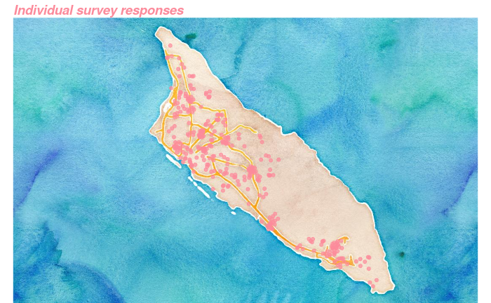

*Source: Cornerstone Economics (2022)*

**Individual survey responses display a comparable age composition as to that of the population of Aruba as registered by the Central Bureau of Statistics (Figure A.4).** This mirroring was achieved through quota sampling. While a quota was not directly applied to gender, figure A.4 also suggests a good balance between female and male responses.

**Figure A.4: Age and gender distribution individual survey response vs. age distribution of the population**

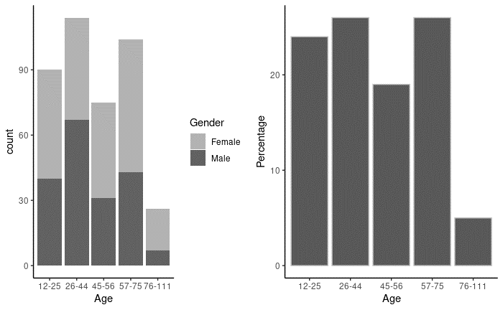

*Source: Cornerstone Economics (2022)*

**The survey among businesses in Aruba focused on insuring representativeness by size of company and captures the relatively large share (78.4%) of business pertaining to the size ‘micro’.** The classification was maintained methodologically consistent with the definitions applied by the European Union, meaning businesses were classified according to their number of employees.

**Figure A.5: Business survey response distribution**

*Source: Cornerstone Economics (2022)*

## 1. Access

Access to communications infrastructures, services and data underpin digital transformation and become more critical as more people and devices go online.

### 1.1 Household broadband access

**In Aruba, 84% of households have purchased subscriptions to fixed broadband services**. Broadband is fundamental for individuals to access the Internet and the global free flow of information. This indicator measures the uptake of broadband connectivity by households.

**Figure 1.1: Share of households with broadband connections**

*Source: OECD, Cornerstone Economics*

### 1.2 Disparity in broadband uptake between urban and rural households

**Households in San Nicolas are 5.1% less likely to have access to broadband internet at home compared to households in Noord.** Ensuring adequate access to communications infrastructures in all geographic areas is essential to bridging connectivity divides that may arise due to country size, topology, and population density, among other factors. This indicator measures the disparity in broadband uptake between urban and rural households. It reflects the share of households that have purchased subscriptions to fixed line (DSL, cable, fiber, satellite, terrestrial fixed wireless, and it is calculated as the share of urban households with broadband Internet access minus the share for rural households.

**The results confirm that the affluence of the region correlates with a disparity in broadband uptake.** Given Aruba’s characteristics as a heavily urbanized SIDS with no discernable classification of urban versus rural, instead the disparity between broadband uptake between the wealthiest region of Noord (shaded in pink) and the most deprived region of San Nicolas Noord and San Nicolas South (shaded in orange) was utilized.

**Figure 1.2.1: Disparity in broadband uptake between Noord and San Nicolas**

*Source: Cornerstone Economics (2022)*

**Relative to other countries, the disparity in broadband uptake in Aruba is below average.** This suggests that the digital divide between households, at least in terms of geographical location, is limited.

**Figure 1.2.2: Disparity in broadband uptake between urban and rural households**

*Source: OECD, Cornerstone Economics*

## 2. Use

The power and potential of digital technologies and data for people, firms and governments depends on their effective use.

### 2.1 Internet users as a share of individuals

**87% of the Aruban adult population is an internet user.** In most OECD countries it currently takes values between 80% and 100% and Aruba in this regard performs slightly above average.

**Figure 2.1: Internet users as a share of individuals**

*Source: OECD, Cornerstone Economics*

### 2.2 Individuals using the internet to interact with public authorities

**About 84% of all individuals aged 16-75 years use the internet to in some form interact with (quasi) public authorities.** Interaction varies, and the uptake is the largest for telecommunication services, followed by the utility companies (WEB and ELMAR). These quasi-public authorities outperform the usage of core government services, such as those of the civil and population registry (CENSO) and the tax department.

**Figure 2.2.1: Uptake of digital government services by individuals**

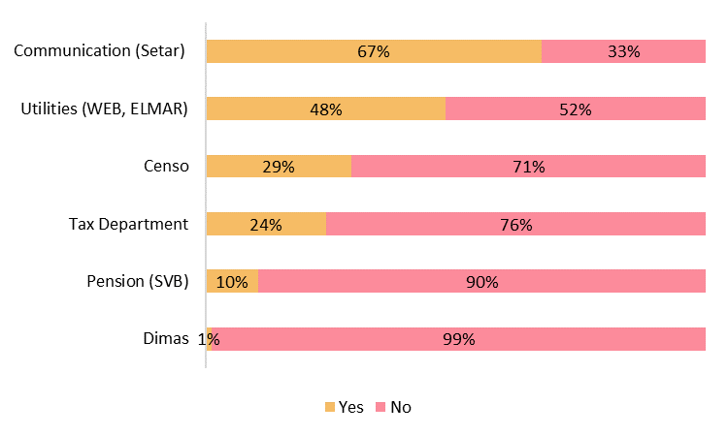

*Source: Cornerstone Economics (2022)*

**Figure 2.2.2: Share of individuals using the internet to interact with public authorities**

*Source: OECD, Cornerstone Economics*

### 2.3 People buying online

**Of internet users, in Aruba only 54% have purchased online in the last 12 months while the country average is 70%.** This indicator measures the prevalence of a relatively sophisticated internet activity, though its level can also reflect the maturity of Aruba’s e-banking and e-payment systems, as well as cultural habits and preferences related to privacy, security and consumer protection for online transactions. An e-commerce purchase describes the purchase of goods or services conducted over computer networks by methods specifically designed for the purpose of receiving or placing orders.

**Figure 2.3: Share of Internet users who have purchased online in the last 12 months**

*Source: OECD, Cornerstone Economics*

### 2.4 Share of small businesses making e-commerce sales

**Roughly about a quarter of small businesses in Aruba engaged on e-commerce sales in the last 12 months.** This appears to be in line with the global average, though it must be noted that other countries may have made significant advances in this area following the COVID-19 crisis.

**Figure 2.4: Share of small businesses making e-commerce sales in the last 12 months**

*Source: OECD, Cornerstone Economics*

### 2.5 Share of businesses with a web presence

**Consistent with the activity of individuals, businesses in Aruba predominantly maintain a web presence on Facebook (77.6%) and to a lesser extent maintain a website (57.5%) or an Instagram presence (55.2%).** While most businesses choose a presence on a combination of social media platforms, twitter is only utilized by 12.7% of businesses.

**Figure 2.5.1: Share of businesses in Aruba by type of web presence**

*Source: Cornerstone Economics (2022)*

**Figure 2.5.2: Share of businesses with a web presence**

*Source: OECD, Cornerstone Economics*

## 3. Innovation

Innovation pushes out the frontier of what is possible in the digital age, driving job creation, productivity, and sustainable growth.

### 3.1 Share of start-up firms

**In Aruba, 19 percent of firms are classified as ‘start-ups’**. Out of the business population, start-up firms were defined as those existing up to 2 years.

**Figure 3.1.1: Share of start-up firms (up to 2 years old) in the business population**

*Source: Cornerstone Economics (2022)*

**Figure 3.1.2: Share of start-up firms (up to 2 years old) in the business population**

*Source: OECD, Cornerstone Economics*

### 3.2 Businesses accepting alternative means of payment

**Of the businesses in Aruba, only a small minority adopt alternative payment methods.** While financial technology has been growing rapidly, fintech provides opportunities to deepen financial development, competition, innovations, and inclusion but also creates new and only partially understood risks. Despite this not being included as an indicator for innovation in the OECD framework, it can be concluded that this type of innovation is only marginally adopted in Aruba.

**Figure 3.2: Adoption of alternative means of payments by businesses on Aruba (in percent)**

*Source: Cornerstone Economics (2022)*

## 4. Jobs

As labor markets evolve, we must ensure that digital transformation leads to more and better jobs and to facilitate just transitions from one job to the next.

### 4.1 Workers receiving employment-based training

**Business report that employment-based training is offered to 79% of employees.** This is the highest share recorded in the country comparison. However, the results are speculative at best due to at least two potential shortcomings: Firstly, the OECD responses date from 2015, which means they are considerably older than the Aruba observations. Secondly, the Aruba sample may be biased due to self-reporting and sample selection.

**Zooming in to the results for Aruba by skill set, what is evident is that low skilled employees are significantly more likely to not receive employment-based training.** Given the economic structure of Aruba, this consideration should factor into inclusive policy making.

**Figure 4.1.1: Percentage share of workers receiving employment-based training, by skill**

**Figure 4.1.2: Share of workers receiving employment-based training**

*Source: OECD, Cornerstone Economics*

## 5. Society

Digital technologies affect society in complex and interrelated ways, and all stakeholders must work together to balance benefits and risks

### 5.1 Individuals aged 55-74 using the Internet

**In Aruba, 94.5% of individuals in the age range between 55 and 75 years old use the internet.** This implies that internet usage in Aruba is significantly higher than the world average.

**Figure 5.1: Percentage of individuals aged 55-74 using the Internet**

*Source: OECD, Cornerstone Economics*

### 5.2 Women as a share of all 16–24-year-olds who can program

**Figure 5.2: Women as a share of all 16–24-year-olds who can program**

*Source: OECD, Cornerstone Economics*

### 5.3 Disparity in Internet use between men and women

**In line with most developed countries, internet use disparity between men and women is very limited and the balance is marginally in favor of women.** The good equality in terms of internet use appears in stark contrast to the situation in male dominant cultures such as India and Indonesia.

**Figure 5.3: Disparity in Internet use between men and women**

*Source: OECD, Cornerstone Economics*

### 5.4 Individuals who use digital equipment at work that telework from home

**With 26% of individuals using digital equipment at work that telework from home once a week or more, Aruba is right on the OECD average.** However, an important caveat to take into consideration is that the OECD data was collected in 2018, which is prior to the COVID pandemic that significantly accelerated the transition to remote work. The expectation therefore is that should this survey be repeated, Aruba would score below the OECD average primarily due to its focus on the tourism service industry which remains largely incompatible with significant remote work.

**Figure 5.4: Percentage of individuals who use digital equipment at work that telework from home once a week or more**

*Source: OECD, Cornerstone Economics*

## 6. Trust

Trust in digital environments is essential; without it, an important source of economic and social progress will be left unexploited.

### 6.1 Internet users experiencing abuse of personal information or privacy violations

**Figure 6.1: Percentage of Internet users experiencing abuse of personal information or privacy violations**

*Source: OECD, Cornerstone Economics*

### 6.2 Individuals not buying online due to payment security concerns

**Figure 6.2: Percentage of individuals not buying online due to payment security concerns**

*Source: OECD, Cornerstone Economics*

**The apparent contradiction between a high percentage of the population being concerned about the abuse of personal information and a seemingly low percentage of individuals that do not participate in purchasing online due to payment security concerns is attributable to binding constraints in access and use.** The survey provides a richer context and suggests that trust in the security of the payment system might not be prevalent due to other, more binding constraints in access and use, namely:

* 10.3% of the population do not have access to a technology device to complete online payments
* 3.0% of the population does not know how to effectuate online payments
* 13.3% of the population do not have access to a credit card or other payment tools to complete online payments.

In short, access and use related issues amount to 26.6% of respondents not being able to effectuate online payments.

### 6.3 businesses in which ICT security and data protection tasks are mainly performed by own employees

**Figure 6.3: Percentage of businesses in which ICT security and data protection tasks are mainly performed by own employees**

*Source: OECD, Cornerstone Economics*

## 7. Market openness

Digital technologies change the way firms compete, trade and invest; market openness creates an enabling environment for digital transformation to flourish.

### 7.1 Share of businesses making ecommerce sales that sell across borders

**Figure 7.1.1: Share of businesses making ecommerce sales that sell across borders - Aruba**

*Source: Cornerstone Economics (2022)*

**Figure 7.1.2: Share of businesses making ecommerce sales that sell across borders - Comparison**

*Source: OECD, Cornerstone Economics*

# Methodology

To inform this study, where possible data was collected from secondary sources, which was supplemented by the execution of two digital divide surveys (Individuals and Businesses).

## Individual survey

The individual survey was launched via a webform, which was accessible on mobile/smartphones and PC/desktops. The data collection period was carried out between the 20th of December 2021 and the 26th of March 2022. The survey was administered by 5 surveyors deployed by Cornerstone Economics with a tablet at strategic public spaces. To facilitate both offline and online data collection, Cornerstone Economics created a separate survey to serve each purpose. To ensure inclusivity, particular care was given to ensure the reach those that may not be connected digitally. With this in mind, surveyors visited elderly care homes to collect data for this specific cohort. Cornerstone Economics performed the data collection, monitoring and analysis. This included merging the online and offline survey data. Responses were visualized and monitored daily (according to stratification criteria) throughout the collection period to enable surveyors to target their efforts on specific age groups that required attention. Data validation methods were designed into the survey form to mitigate against data entry errors and/or unintentional outliers.

Given the success in obtaining representative sub samples according to age, gender and geographical region, the analysis did not require re-weighing the data.

## Business survey

The business survey was launched digitally via a webform, during the collection period that lasted between the 31st of January to the 5th of April 2022. Presentiveness was pursued by business size, according to the definition by the European Union (Mice, Small, Medium, Large enterprises). Given the challenge of securing responses, organization were solicited to participate through diverse channels. Both Cornerstone Economics and Futura Foundation utilized social media (facebook and twitter), while the Aruba Chamber of Commerce sent out a direct email to its business registry. Cornerstone Economics performed the data collection, monitoring and analysis. Data validation methods were designed into the survey form to mitigate against data entry errors and/or unintentional outliers.

## Calculation of digital divide estimates

Observations for other countries for benchmarking purposes were obtained from OECD data < https://goingdigital.oecd.org/ >. Unfortunately, comparative data was not available for Caribbean peers which share more similar economic characteristics. And additional shortcoming is also that depending on availability per country, the data was collected between 2011 and 2021.

Not all indicators listed by OECD were attainable for Aruba, as some indicators could not be collected through surveys and thus relied on third parties to provide.

To facilitate comparison, all data were normalized to be between the values 0 and 1, according to the formula: zi = (xi – min(x)) / (max(x) – min(x)).

<back page>

1. World Bank (2022). Post-Disaster Needs Assessment Bonaire. Socioeconomic assessment March-December 2022.